Table 11. Staggered DiD Estimates on granted patent application
DV: Patent applications | (1)  All firms | (2)  No prior patent | (3)  Prior patent | (4)  Early stage | (5)  Late stage
Simple ATT | -0.226** | -0.05 | -0.817** | -0.138* | -0.528**
 | (0.024) | (0.326) | (0.010) | (0.072) | (0.033)
Aggregated event study ATT | -0.190** | -0.034 | -0.650** | -0.07 | -0.531**
 | (0.016) | (0.325) | (0.011) | (0.237) | (0.013)
Controls | Yes | Yes | Yes | Yes | Yes
Region FE | Yes | Yes | Yes | Yes | Yes
Industry FE | Yes | Yes | Yes | Yes | Yes
Observations | 88,547 | 83,757 | 75,739 | 83,285 | 76,211
Firms | 7,273 | 6,892 | 6,255 | 6,860 | 6,287
Control | Never treat | Never treat | Never treat | Never treat | Never treat

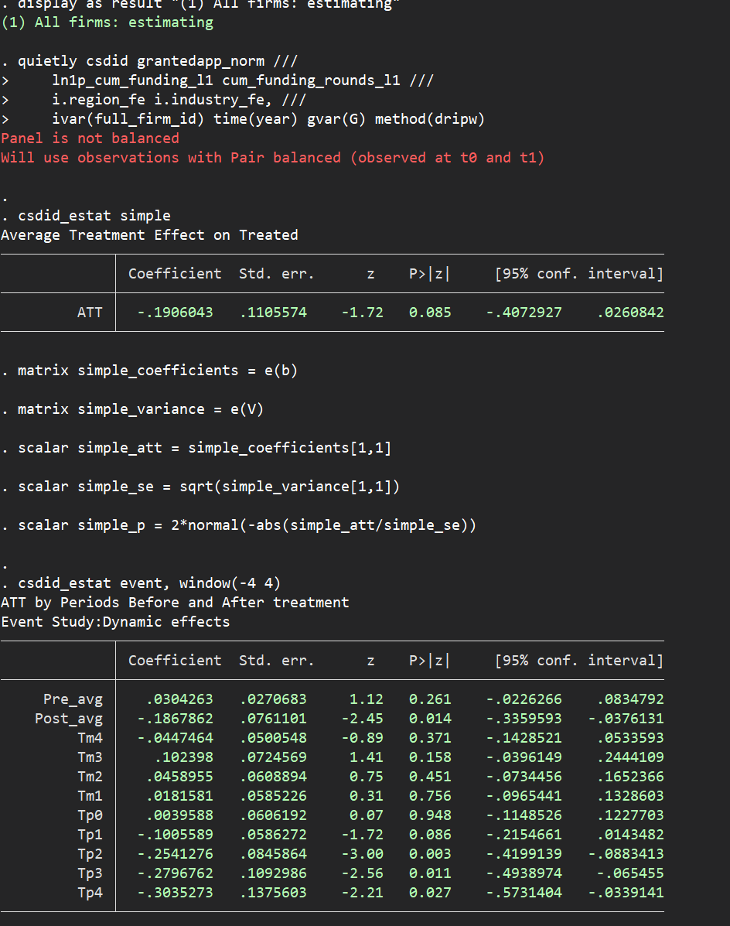

Table 12. Staggered DiD Estimates on forward citation
DV: Patent applications | (1)  All firms | (2)  No prior patent | (3)  Prior patent | (4)  Early stage | (5)  Late stage
Simple ATT | 0.248 | 1.157 | -2.263 | 0.767 | -1.670
 | (0.836) | (0.452) | (0.153) | (0.612) | (0.153)
Aggregated event study ATT | -0.717* | -0.045 | -2.183 | -0.251 | -2.130*
 | (0.087) | (0.754) | (0.142) | (0.344) | (0.082)
Controls | Yes | Yes | Yes | Yes | Yes
Region FE | Yes | Yes | Yes | Yes | Yes
Industry FE | Yes | Yes | Yes | Yes | Yes
Observations | 88,547 | 83,757 | 75,739 | 83,285 | 76,211
Firms | 7,273 | 6,892 | 6,255 | 6,860 | 6,287
Control | Never treat | Never treat | Never treat | Never treat | Never treat

Table 3-1. TWFE estimates of VD intensity and Post-VD patent applications
DV: Log(Granted patent applications) | (1)  All firms | (2)  No prior patent | (3)  Prior patent | (4)  Early stage
VD amount x Post | -0.000 | -0.000** | -0.000 | -0.000**
 | (0.407) | (0.031) | (0.338) | (0.032)
VD amount x Post x Prior patent |  | 0.000 |  | 0.000
 |  | (0.853) |  | (0.868)
VD amount x Post x Early stage |  |  | 0.000 | 0.000
 |  |  | (0.696) | (0.988)
Post x Prior patent |  | -0.203*** |  | -0.203***
 |  | (0.000) |  | (0.000)
Post x Early stage |  |  | -0.017 | -0.020
 |  |  | (0.618) | (0.503)
Post | 0.011 | 0.033*** | 0.012 | 0.034***
 | (0.196) | (0.000) | (0.181) | (0.000)
Lagged prior patent | -0.097* | -0.044 | -0.097* | -0.044
 | (0.089) | (0.471) | (0.089) | (0.471)
Lagged early stage | -0.002 | -0.002 | -0.001 | -0.001
 | (0.728) | (0.765) | (0.801) | (0.858)
Log(Total lagged funding amount) | 0.004*** | 0.003*** | 0.004*** | 0.003***
 | (0.000) | (0.001) | (0.000) | (0.001)
Log(number of lagged funding rounds) | -0.018* | -0.019* | -0.017 | -0.018*
 | (0.097) | (0.070) | (0.102) | (0.077)
Firm FE | Yes | Yes | Yes | Yes
Year FE | Yes | Yes | Yes | Yes
Observations | 12,707 | 12,707 | 12,707 | 12,707
Firms | 1,235 | 1,235 | 1,235 | 1,235
Within R² | 0.018 | 0.039 | 0.018 | 0.039

Table 3-2. TWFE estimates of VD intensity and Post-VD patent applications
DV: Log(Granted patent applications) | (1)  All firms | (2)  No prior patent | (3)  Prior patent | (4)  Early stage
Log(VD amount) x Post | -0.000 | -0.001 | -0.001 | -0.002
 | (0.984) | (0.244) | (0.778) | (0.154)
Log(VD amount) x Post x Prior patent |  | 0.029 |  | 0.028
 |  | (0.208) |  | (0.207)
Log(VD amount) x Post x Early stage |  |  | 0.007 | 0.006
 |  |  | (0.553) | (0.499)
Post x Prior patent |  | -0.641* |  | -0.640*
 |  | (0.069) |  | (0.067)
Post x Early stage |  |  | -0.114 | -0.108
 |  |  | (0.536) | (0.470)
Post | 0.011 | 0.052*** | 0.020 | 0.061***
 | (0.701) | (0.004) | (0.473) | (0.004)
Lagged prior patent | -0.097* | -0.046 | -0.097* | -0.046
 | (0.090) | (0.447) | (0.090) | (0.448)
Lagged early stage | -0.002 | -0.002 | -0.001 | -0.001
 | (0.725) | (0.766) | (0.810) | (0.867)
Log(Total lagged funding amount) | 0.004*** | 0.003*** | 0.004*** | 0.003***
 | (0.000) | (0.001) | (0.000) | (0.001)
Log(number of lagged funding rounds) | -0.017* | -0.019* | -0.017* | -0.018*
 | (0.097) | (0.065) | (0.100) | (0.069)
Firm FE | Yes | Yes | Yes | Yes
Year FE | Yes | Yes | Yes | Yes
Observations | 12,707 | 12,707 | 12,707 | 12,707
Firms | 1,235 | 1,235 | 1,235 | 1,235
Within R² | 0.018 | 0.040 | 0.018 | 0.040

Table 3-3. TWFE estimates of VD intensity and Post-VD patent applications
DV: Log(Granted patent applications) | (1)  All firms | (2)  No prior patent | (3)  Prior patent | (4)  Early stage
VD-to-pre-VD equity ratio x Post | 0.000 | -0.000* | -0.000 | -0.000
 | (0.700) | (0.076) | (0.997) | (0.132)
VD-to-pre-VD equity ratio x Post x Prior patent |  | 0.035 |  | 0.033
 |  | (0.572) |  | (0.581)
VD-to-pre-VD equity ratio x Post x Early stage |  |  | 0.001 | 0.001
 |  |  | (0.473) | (0.420)
Post x Prior patent |  | -0.247*** |  | -0.247***
 |  | (0.001) |  | (0.001)
Post x Early stage |  |  | -0.030 | -0.031
 |  |  | (0.525) | (0.422)
Post | 0.010 | 0.037*** | 0.013 | 0.039***
 | (0.335) | (0.000) | (0.274) | (0.000)
Lagged prior patent | -0.096 | -0.036 | -0.096 | -0.036
 | (0.309) | (0.715) | (0.309) | (0.717)
Lagged early stage | 0.003 | 0.003 | 0.004 | 0.004
 | (0.628) | (0.619) | (0.536) | (0.524)
Log(Total lagged funding amount) | 0.005 | 0.004 | 0.005 | 0.004
 | (0.114) | (0.186) | (0.114) | (0.188)
Log(number of lagged funding rounds) | -0.020 | -0.022 | -0.019 | -0.021
 | (0.155) | (0.120) | (0.158) | (0.124)
Firm FE | Yes | Yes | Yes | Yes
Year FE | Yes | Yes | Yes | Yes
Observations | 7,850 | 7,850 | 7,850 | 7,850
Firms | 755 | 755 | 755 | 755
Within R² | 0.018 | 0.042 | 0.018 | 0.043

Table 3-4. TWFE estimates of VD intensity and Post-VD patent applications
DV: Log(Granted patent applications) | (1)  All firms | (2)  No prior patent | (3)  Prior patent | (4)  Early stage
VD-to-prior equity round ratio x Post | 0.000** | -0.000 | 0.000** | -0.000
 | (0.015) | (0.752) | (0.023) | (0.582)
VD-to-prior equity round ratio x Post x Prior patent |  | -0.010 |  | -0.010
 |  | (0.720) |  | (0.713)
VD-to-prior equity round ratio x Post x Early stage |  |  | 0.000 | 0.000
 |  |  | (0.514) | (0.768)
Post x Prior patent |  | -0.210*** |  | -0.210***
 |  | (0.000) |  | (0.000)
Post x Early stage |  |  | -0.019 | -0.022
 |  |  | (0.610) | (0.501)
Post | 0.013 | 0.036*** | 0.014 | 0.038***
 | (0.193) | (0.000) | (0.176) | (0.000)
Lagged prior patent | -0.061 | -0.000 | -0.061 | -0.000
 | (0.367) | (0.995) | (0.368) | (0.997)
Lagged early stage | -0.000 | 0.000 | 0.000 | 0.001
 | (0.965) | (0.981) | (0.968) | (0.897)
Log(Total lagged funding amount) | 0.005*** | 0.004*** | 0.005*** | 0.004***
 | (0.001) | (0.004) | (0.001) | (0.004)
Log(number of lagged funding rounds) | -0.030** | -0.031** | -0.030** | -0.030**
 | (0.019) | (0.013) | (0.019) | (0.014)
Firm FE | Yes | Yes | Yes | Yes
Year FE | Yes | Yes | Yes | Yes
Observations | 10,228 | 10,228 | 10,228 | 10,228
Firms | 982 | 982 | 982 | 982
Within R² | 0.015 | 0.040 | 0.015 | 0.040

Table 3-5. TWFE estimates of VD intensity and Post-VD patent applications
DV: Log(Granted patent applications) | (1)  All firms | (2)  No prior patent | (3)  Prior patent | (4)  Early stage
VD share of total capital x Post | 0.019 | -0.012 | -0.007 | -0.035**
 | (0.523) | (0.281) | (0.807) | (0.020)
VD share of total capital x Post x Prior patent |  | 0.100 |  | 0.104
 |  | (0.705) |  | (0.687)
VD share of total capital x Post x Early stage |  |  | 0.268 | 0.238
 |  |  | (0.131) | (0.103)
Post x Prior patent |  | -0.257** |  | -0.256**
 |  | (0.014) |  | (0.011)
Post x Early stage |  |  | -0.128 | -0.116
 |  |  | (0.189) | (0.130)
Post | 0.005 | 0.040*** | 0.015 | 0.049***
 | (0.784) | (0.000) | (0.342) | (0.000)
Lagged prior patent | -0.096 | -0.036 | -0.094 | -0.035
 | (0.308) | (0.717) | (0.319) | (0.727)
Lagged early stage | 0.003 | 0.003 | 0.004 | 0.004
 | (0.673) | (0.662) | (0.570) | (0.561)
Log(Total lagged funding amount) | 0.005 | 0.004 | 0.005 | 0.005
 | (0.164) | (0.203) | (0.139) | (0.178)
Log(number of lagged funding rounds) | -0.013 | -0.016 | -0.013 | -0.016
 | (0.387) | (0.288) | (0.372) | (0.277)
Firm FE | Yes | Yes | Yes | Yes
Year FE | Yes | Yes | Yes | Yes
Observations | 8,003 | 8,003 | 8,003 | 8,003
Firms | 773 | 773 | 773 | 773
Within R² | 0.017 | 0.041 | 0.019 | 0.042

Table 3-6. TWFE estimates of VD intensity and Post-VD patent applications
DV: Log(Granted patent applications) | (1)  All firms | (2)  No prior patent | (3)  Prior patent | (4)  Early stage
Number of subsequent VD rounds x Post | 0.008 | 0.000 | 0.009 | 0.001
 | (0.211) | (0.922) | (0.194) | (0.754)
Number of subsequent VD rounds x Post x Prior patent |  | 0.070 |  | 0.073
 |  | (0.517) |  | (0.508)
Number of subsequent VD rounds x Post x Early stage |  |  | -0.008 | -0.006
 |  |  | (0.601) | (0.745)
Post x Prior patent |  | -0.205*** |  | -0.205***
 |  | (0.000) |  | (0.000)
Post x Early stage |  |  | -0.008 | -0.016
 |  |  | (0.799) | (0.535)
Post | 0.007 | 0.029*** | 0.007 | 0.030***
 | (0.341) | (0.000) | (0.348) | (0.000)
Lagged prior patent | -0.114** | -0.063 | -0.114** | -0.063
 | (0.026) | (0.253) | (0.027) | (0.253)
Lagged early stage | -0.003 | -0.003 | -0.003 | -0.002
 | (0.571) | (0.556) | (0.605) | (0.633)
Log(Total lagged funding amount) | 0.003*** | 0.003*** | 0.003*** | 0.003***
 | (0.000) | (0.001) | (0.000) | (0.001)
Log(number of lagged funding rounds) | -0.017* | -0.018* | -0.017* | -0.017*
 | (0.067) | (0.054) | (0.067) | (0.059)
Firm FE | Yes | Yes | Yes | Yes
Year FE | Yes | Yes | Yes | Yes
Observations | 14,624 | 14,624 | 14,624 | 14,624
Firms | 1,440 | 1,440 | 1,440 | 1,440
Within R² | 0.020 | 0.041 | 0.020 | 0.041

Table 3-7. TWFE estimates of VD intensity and Post-VD patent applications
DV: Log(Granted patent applications) | (1)  All firms | (2)  No prior patent | (3)  Prior patent | (4)  Early stage
Log(Subsequent VD amount) x Post | 0.001 | 0.000 | 0.001 | 0.000
 | (0.306) | (0.679) | (0.375) | (0.864)
Log(Subsequent VD amount) x Post x Prior patent |  | 0.005 |  | 0.005
 |  | (0.527) |  | (0.523)
Log(Subsequent VD amount) x Post x Early stage |  |  | 0.001 | 0.001
 |  |  | (0.746) | (0.578)
Post x Prior patent |  | -0.204*** |  | -0.205***
 |  | (0.000) |  | (0.000)
Post x Early stage |  |  | -0.014 | -0.021
 |  |  | (0.665) | (0.446)
Post | 0.008 | 0.030*** | 0.009 | 0.032***
 | (0.321) | (0.000) | (0.296) | (0.000)
Lagged prior patent | -0.113** | -0.059 | -0.113** | -0.059
 | (0.031) | (0.289) | (0.031) | (0.289)
Lagged early stage | -0.002 | -0.002 | -0.002 | -0.002
 | (0.638) | (0.638) | (0.705) | (0.747)
Log(Total lagged funding amount) | 0.003*** | 0.003*** | 0.003*** | 0.003***
 | (0.000) | (0.001) | (0.000) | (0.001)
Log(number of lagged funding rounds) | -0.019* | -0.020** | -0.019* | -0.019**
 | (0.054) | (0.043) | (0.054) | (0.045)
Firm FE | Yes | Yes | Yes | Yes
Year FE | Yes | Yes | Yes | Yes
Observations | 14,108 | 14,108 | 14,108 | 14,108
Firms | 1,389 | 1,389 | 1,389 | 1,389
Within R² | 0.020 | 0.041 | 0.020 | 0.041

Table 3-8. TWFE estimates of VD intensity and Post-VD patent applications
DV: Log(Granted patent applications) | (1)  All firms | (2)  No prior patent | (3)  Prior patent | (4)  Early stage
Log(cumulative VD exposure) x Post | 0.000 | -0.001 | -0.000 | -0.002
 | (0.829) | (0.275) | (0.932) | (0.156)
Log(cumulative VD exposure) x Post x Prior patent |  | 0.026 |  | 0.026
 |  | (0.223) |  | (0.221)
Log(cumulative VD exposure) x Post x Early stage |  |  | 0.007 | 0.006
 |  |  | (0.438) | (0.404)
Post x Prior patent |  | -0.613* |  | -0.612*
 |  | (0.070) |  | (0.068)
Post x Early stage |  |  | -0.126 | -0.115
 |  |  | (0.447) | (0.400)
Post | 0.005 | 0.051*** | 0.015 | 0.061***
 | (0.880) | (0.002) | (0.600) | (0.003)
Lagged prior patent | -0.095 | -0.044 | -0.095 | -0.043
 | (0.102) | (0.480) | (0.102) | (0.482)
Lagged early stage | -0.001 | -0.001 | -0.001 | -0.000
 | (0.819) | (0.869) | (0.920) | (0.983)
Log(Total lagged funding amount) | 0.004*** | 0.003*** | 0.004*** | 0.003***
 | (0.000) | (0.001) | (0.000) | (0.001)
Log(number of lagged funding rounds) | -0.019* | -0.021* | -0.019* | -0.020*
 | (0.077) | (0.054) | (0.078) | (0.056)
Firm FE | Yes | Yes | Yes | Yes
Year FE | Yes | Yes | Yes | Yes
Observations | 12,348 | 12,348 | 12,348 | 12,348
Firms | 1,198 | 1,198 | 1,198 | 1,198
Within R² | 0.018 | 0.040 | 0.018 | 0.040

Table 4.
DV: Log(Granted patent applications) | (1)  All firms | (2)  No prior patent | (3)  Prior patent | (4)  Early stage
Log(cumulative VD exposure) x Post | 0.001 | -0.001 | 0.004 | -0.002
 | (0.531) | (0.141) | (0.227) | (0.600)
Log(cumulative VD exposure) x Post x Prior patent |  | 0.013*** |  | 0.014***

Stage | VD=0 | VD=1 | Total | VD-backed firms within stage
Seed | 415 | 579 | 994 | 58.25%
Series A | 402 | 366 | 768 | 47.66%
Series B | 300 | 220 | 520 | 42.31%
Series C+ | 293 | 245 | 538 | 45.54%
Total | 1,410 | 1,410 | 2,820 | 50.00%

Figure 1. Diagnostic analysis for the staggered DID Design
(a) Mean plots of granted patent applications per firm-year
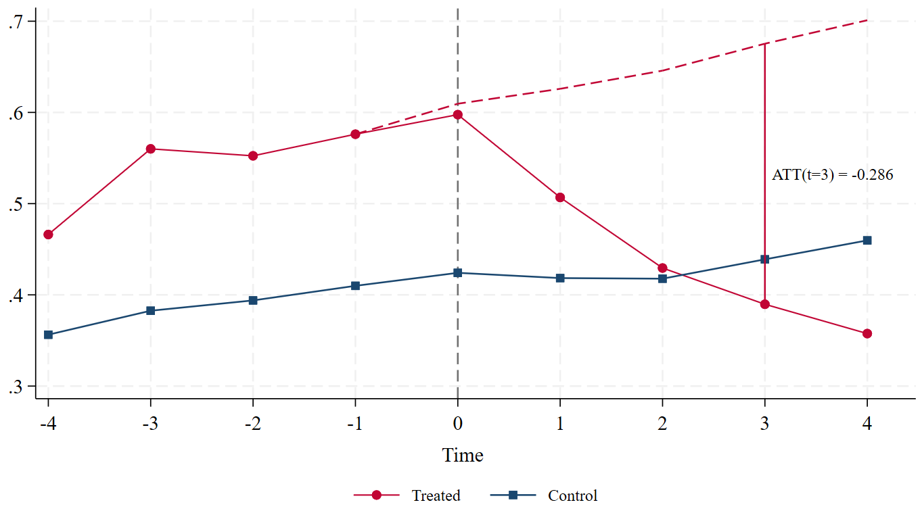
(b) Dynamic ATT and event study plots
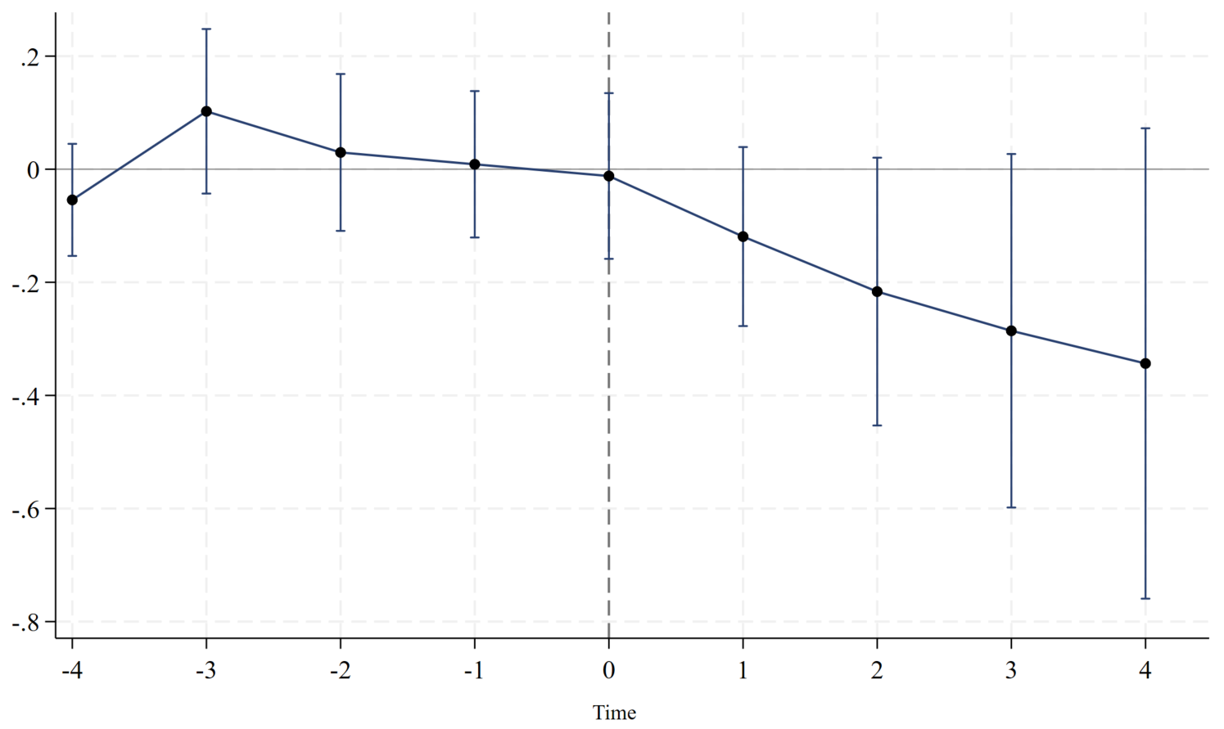
Note: Panel A shows observed and estimated counterfactual outcome trajectories while Panel B demonstrates Callaway–Sant’Anna event-study estimates. Panel A shows the mean annual number of ultimately granted patent applications for VD-backed and VC-only-backed firms relative to the year of first VD. The red dashed line represents the estimated counterfactual trajectory for VD-backed firms in the absence of VD, constructed using the Callaway and Sant’Anna (2021) event-time ATT estimates. Panel B reports the event-time ATT estimates, with vertical bars representing 95% confidence intervals. The horizontal line denotes zero treatment effect. Event time is defined relative to the year of first VD, with t=0 indicating the first VD year. Never-treated firms serve as the comparison group.

Figure 2. Heterogeneous event study estimates of the effects of VD on granted patent applications
(a) By prior technological assets
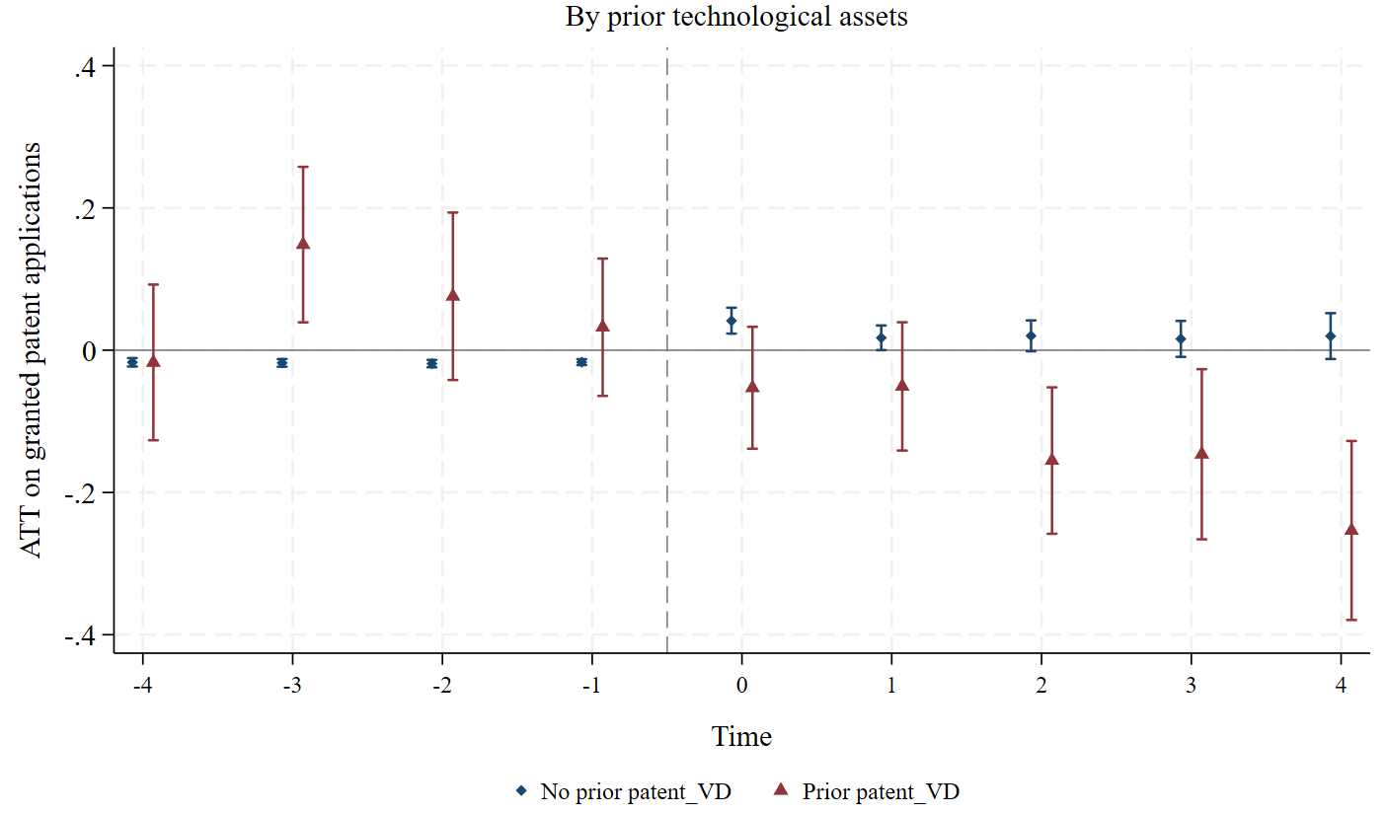
(a) By funding stage
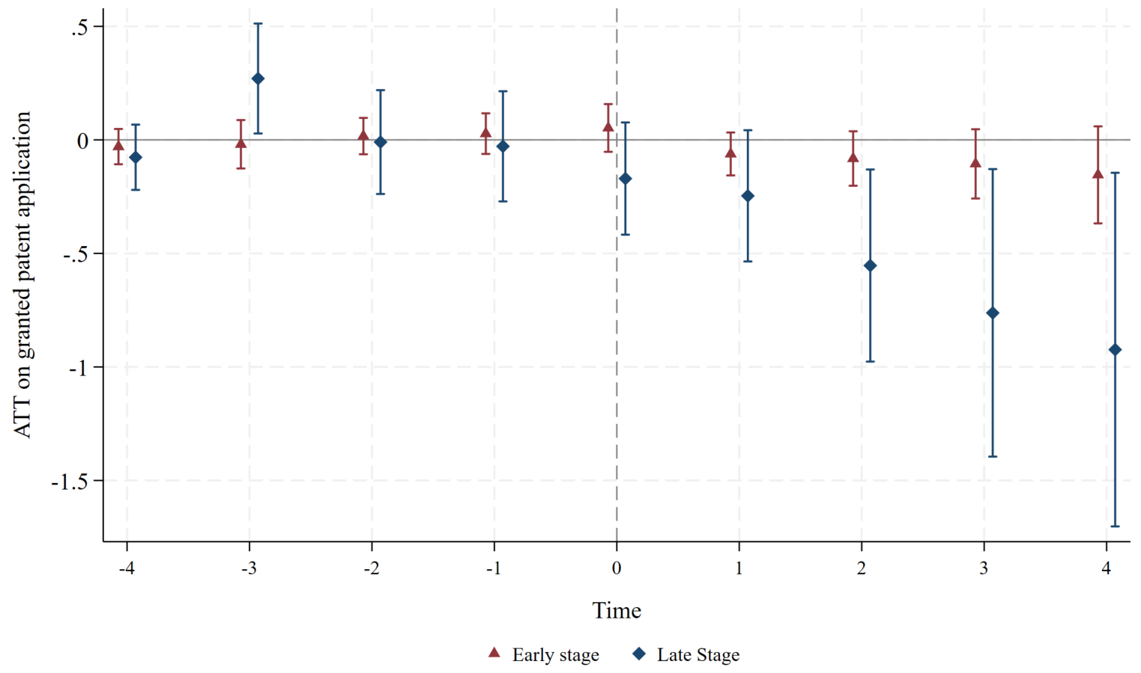
Note: This figure presents heterogeneous event study estimates of the effects of VD on granted patent applications by prior patent status (Panel a) and funding stage (Panel b). Event time is relative to the first VD financing, with t= -1 as the omitted reference period. Bands indicate 95% confidence intervals based on firm-level clustered standard errors.

Figure 3. Event study estimates across alternative estimators
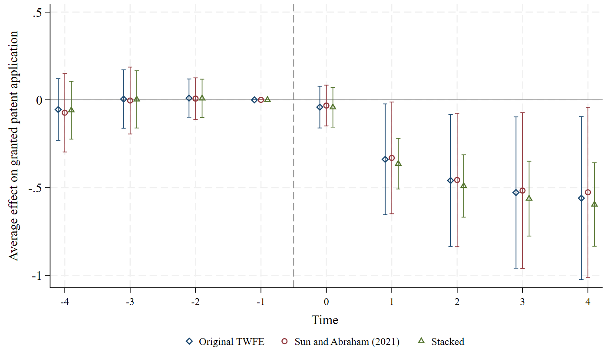
Note: This figure shows event time estimates from a fully saturated event study specification using three alternative estimators. The treatment indicator, VD, is interacted with indicators for each year relative to a firm’s first VD indicator, with t = −1 serving as the omitted reference period. All specifications include firm and year fixed effects and the full set of time varying controls used in the main analysis. Never-treated firms serve as the comparison group. Bands indicate 95% confidence intervals constructed from firm-level clustered standard errors. The p-value from an F-test of joint significance on the original TWFE pre-trend estimates is 0.857.

